Architecture Design
for
Online Food Delivery System
Version 1.1 approved
Prepared by Nica David-Andrei
Necsulea Andrei-Mihai
Onofrei Alexandru Gabriel
UCV
25th March 2026
Table of Contents
Table of Contents ii
Revision History ii
1. Use-Case 1
2. Activity Diagram 2
3. Class Diagram 4
4. Entity Relationship Diagram + Relational Model 5
5. Task list 6

Revision History
Name | Date | Reason For Changes | Version
Nica David-Andrei  Necsulea Andrei-Mihai  Onofrei Alexandru-Gabriel | 25.03.2026 | Initial document creation for Architecture Design | 1.0
Nica David-Andrei  Necsulea Andrei-Mihai  Onofrei Alexandru-Gabriel | 26.03.2026 | Completing the relational model + tasks list in Jira | 1.1

Use-Case

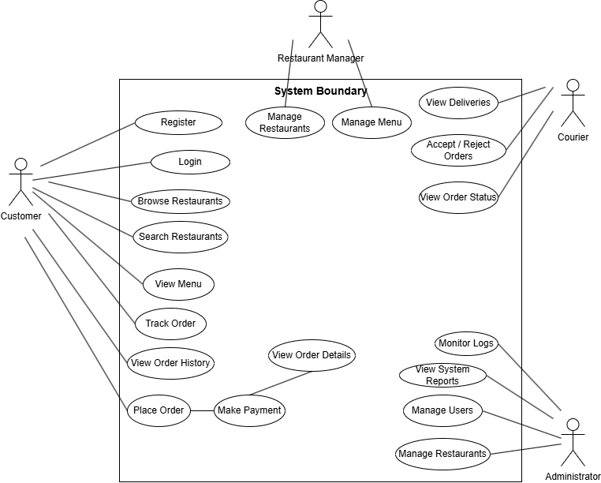

Activity Diagram

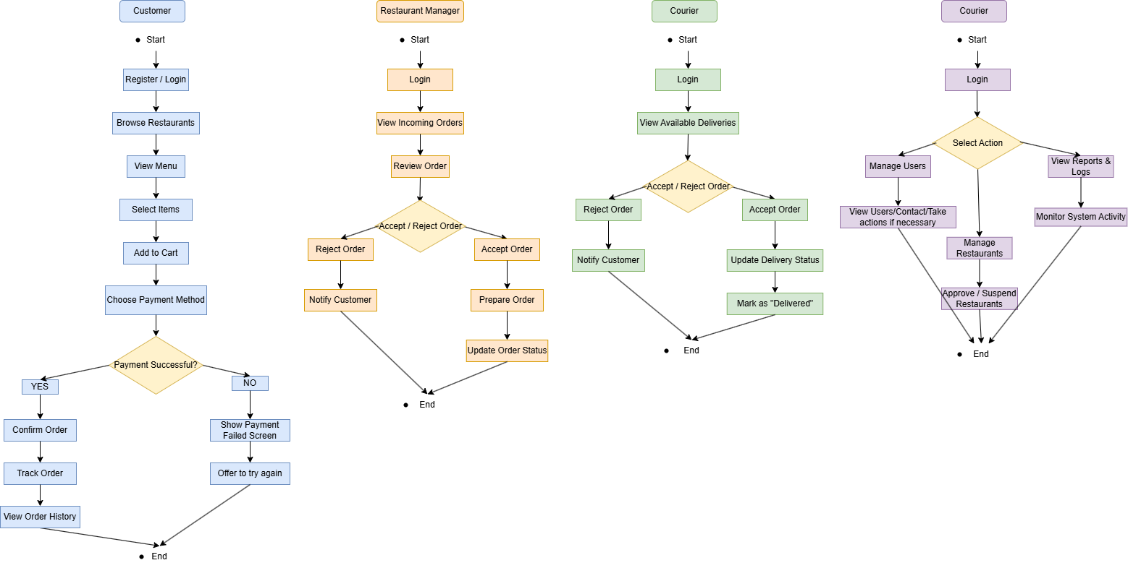

Class Diagram
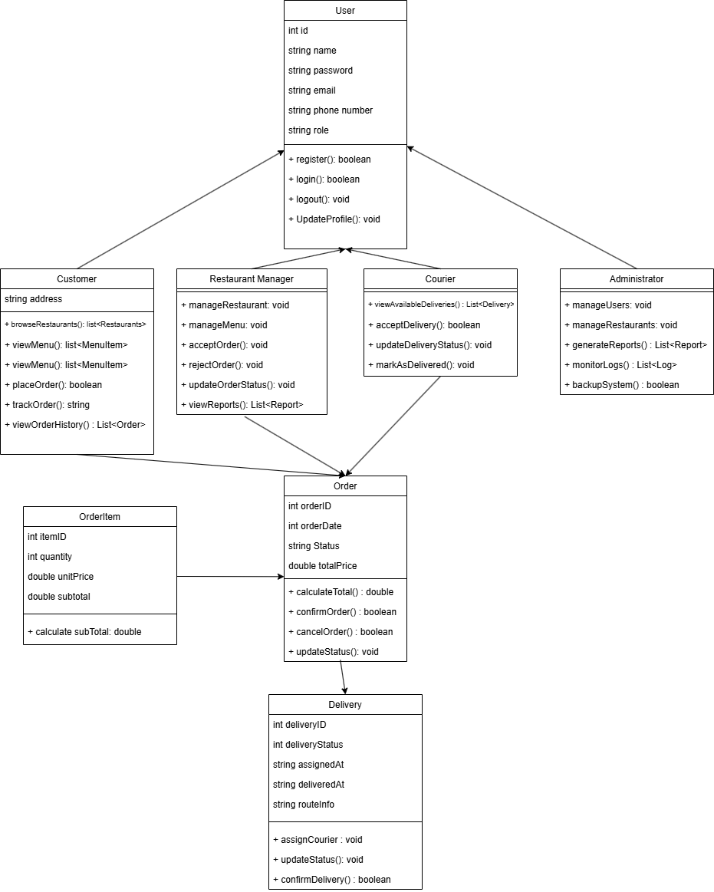

Entity Relationship Diagram + Relational Model
ERD for Online Food Delivery System
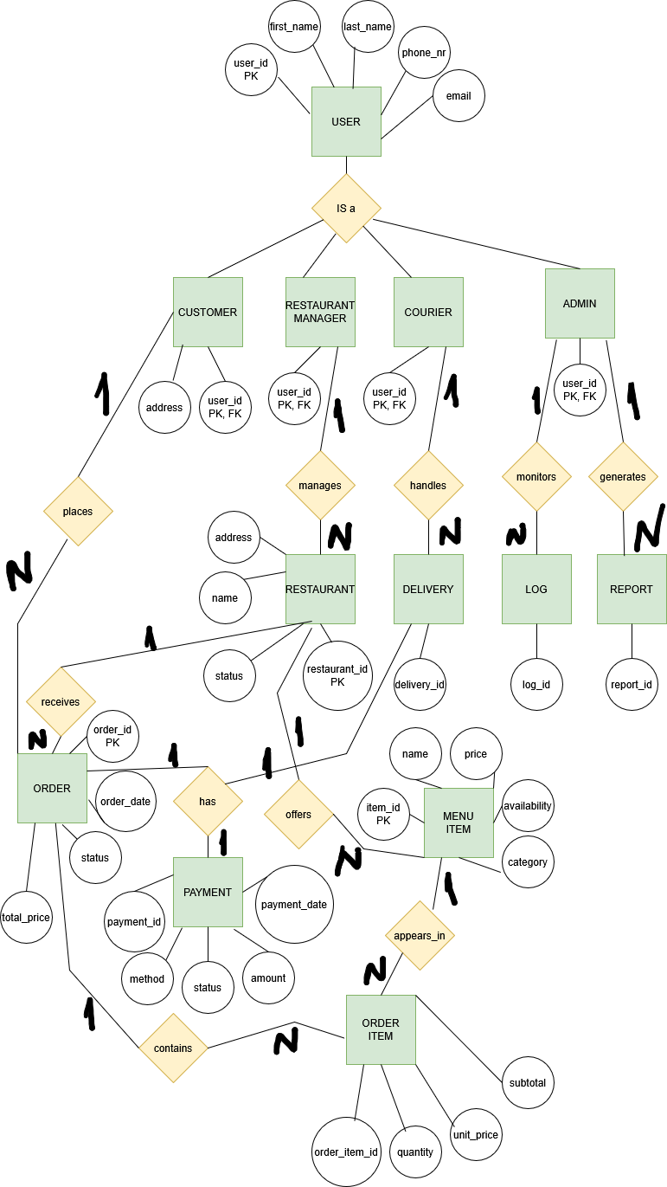

Relational Model for Online Food Delivery System based on the ERD

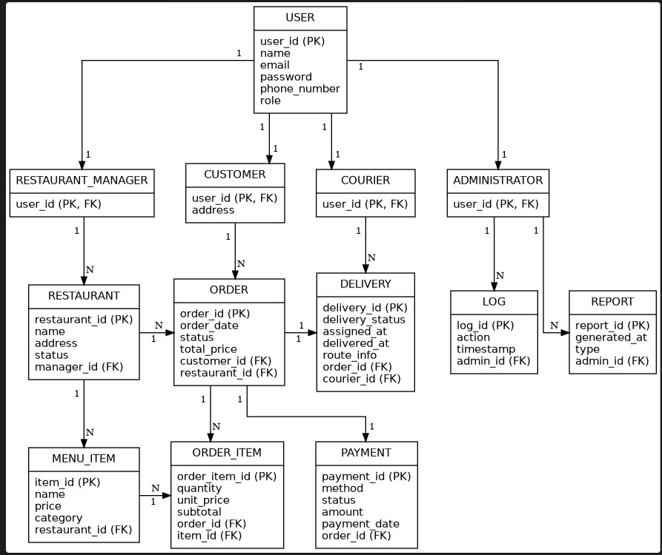

Task list
https://fooddeliverysystemse.atlassian.net/jira/software/projects/KAN/boards/2

